Tutorial 6
- What is a collision domain?
- What is a broadcast domain?
- Indicate the purpose of a hub.
- What are the limitations of a hub
- What are the benefits of using a switch instead of a hub?
- Using the network diagram in Figure 1 describe how SW-1 built the switching table show in Figure 2.
- Describe how the switch uses the table in Figure 2 to forward traffic.
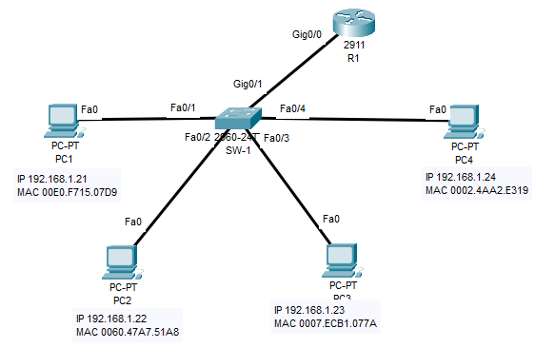
Figure 1 Network topology
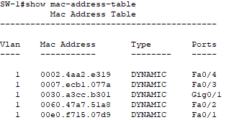
Figure 2 Switching table

